Negative-thermal-expansion-induced graphenization of buffer layer on SiC

Wataru Norimatsu,^{1*} Jianfeng Bao,² Takahiro Ito,³ and Michiko Kusunoki³

¹Department of Applied Chemistry, Nagoya University, Japan

²Institute of Materials and Systems for Sustainability, Nagoya University, Japan

³Synchrotron Radiation Research Center, Nagoya University, Japan

*E-Mail: w_norimatsu@imass.nagoya-u.ac.jp

Thermal decomposition of SiC is one of the most promising techniques to obtain wafer-scale single-crystalline graphene on the semi-insulating substrate. The electron mobility of graphene on SiC decreases with increasing temperature, which is due to the phonon scattering by the interfacial graphene-like buffer layer (BL). This fact indicates that the decoupling of graphene from the substrate would improve the electronic properties. The most popular technique for decoupling is the hydrogen intercalation into the interface, which converts the BF into graphene.¹ In this study, we report on a novel decoupling technique. We focused on the interesting fact that graphene has a negative thermal expansion coefficient, while the SiC substrate has a positive value. It suggests that when we cool the BF on SiC, the BF expands, but SiC shrinks. We then expected that the rapid-cooling would physically break the bonds between them.
We prepared the BL sample by heating the 4H-SiC single crystal substrate at 1600 ºC in the atmospheric pressure of Ar. We then heated the BL sample at 900 ºC in vacuum and then dropped it into the liquid nitrogen (-196 ºC) bath.
Figure 1 shows the atomic force microscope (AFM) images, Raman spectra, and angle-resolved photoemission spectroscopy (ARPES) results of the sample before and after rapid-cooling from 900 ºC to -196 ºC. The AFM results show no distinct difference between them. In the Raman spectra, the sharp 2D band peak appeared at 2688 cm⁻¹, which was not present before rapid-cooling, indicating the conversion of the BL to monolayer graphene. The ARPES results also showed that the BL was converted to monolayer graphene. The rapidly-cooled graphene thus obtained was homogeneous, with less strain, hole-doped, and free from interfacial phonon scattering.²
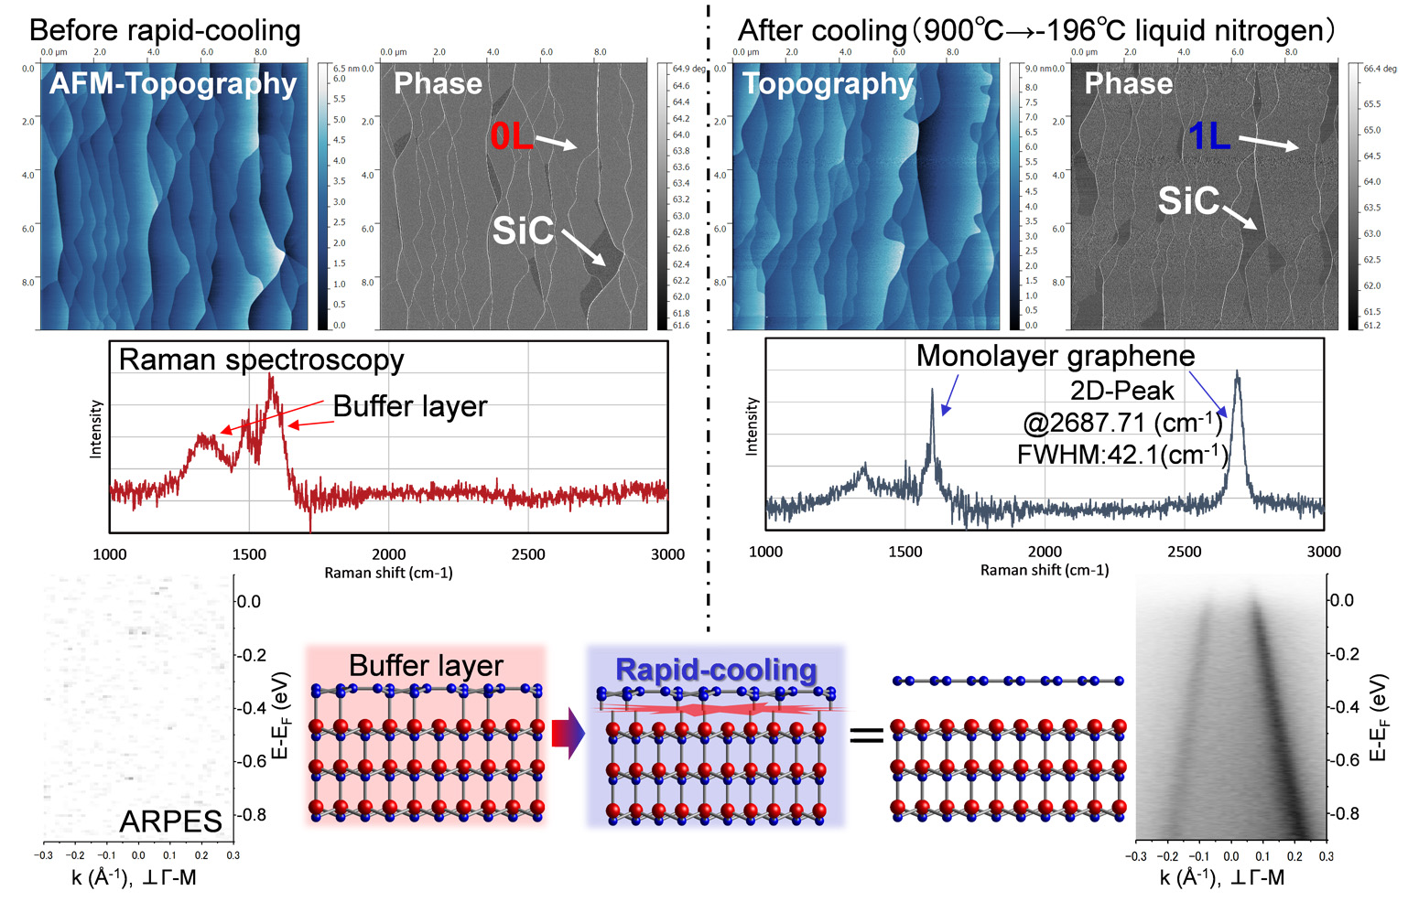
Figure 1 AFM images, Raman spectra, and ARPES spectra before and after the rapid-cooling treatment.

- C. Riedl, et al., Phys. Rev. Lett., 103, 246804 (2009).
- J. Bao, W. Norimatsu, H. Iwata, K. Matsuda, T. Ito, and M. Kusunoki, Phys. Rev. Lett., 117, 205501 (2016).

